

*BUSINESS STRATEGIES BY USING DATA SCIENCE*

***BUSINESS******STRATEGIES BY USING DATA SCIENCE***

*Agenda*

1. Introduction
2. Problem statement and Data Source
3. Objective & Methodology
4. Solution Description
5. Impact

1.introduction

A man has taken a shop in Rent near BTM Layout, Bangalore, not in the main road but as a local shop. The rent of the shop is 14000 per month. The man took the shop to sell fast food like - Biryani, Maggie, Egg Bhujia, Omlets, Chicken Kabab etc.

In the first 3 months he made a profit of around 100000, with a sale of around 300000. But, after 4-5 months he was getting huge loses in his business. He used to sell veg items in starting of business (first 2 months). But, after that he was not able to get enough profits through veg items. And, finally he was could not able to pay his shop rent for 2 months. Now we have to use some business strategies based on data collected by online, swiggy, Zomato and google surveys.

2.Problem statement and Data Source

Now we can see our client is facing lot of problems regarding to business and he is getting more loss by selling food at mentioned location. We have to collect the data from online google, Swiggy, Zomato and google forms. Based on data of people they are living in BTM layout Bangalore, based on their desired curries and food habits we have to change our business strategies.

3.Objective & Methodology

We have to made our client to get profits by using proper business strategies that are based on our proper investigation and data collecting by using different types of sources. We have to get the business into profits.

4.Solution Description

* Analysis of Data based on different food habits
* Understanding the current food habits of BTM layout people
* Knowing number count of vegetarians and non-vegetarians
* Getting data from food apps to know for which type of food they are more attractive and made more orders
* Based on people desired food types, getting ready to available all time without no shortage
* Introducing business into food apps

5.Business Impact

* Reduce the investment on un-necessary food items
* Getting high returns within months

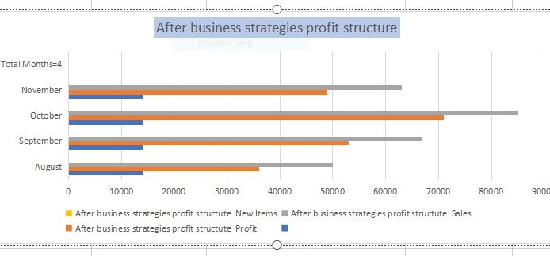

* Concentrating on current food habits of people
* Increasing profits by 20% when compared to loss days

THANK YOU

Yadagiri Konda